To investigate the spatial distribution characteristics of ghost rooms, this part of research select data from the year 2023 for spatial clustering analysis.

The first step involves filtering out the points corresponding to ghost rooms from the dataset. Subsequently, both kernel density analysis and HDBSCAN analysis are performed.

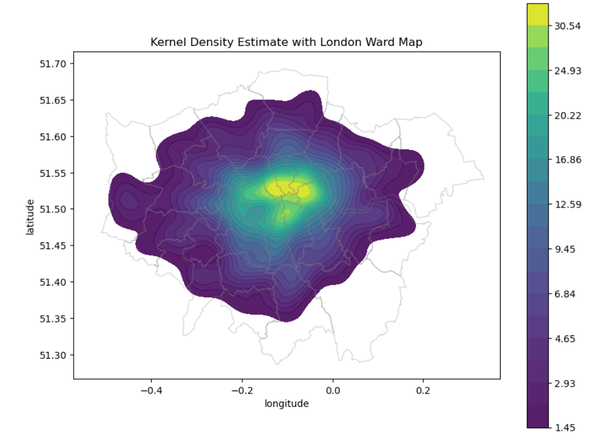

From the kernel density analysis in the above figure, we can observe that in the central areas of London, particularly in the Camden, Islington, Hackney, and Tower Hamlets regions, the density of ghost room points is significantly higher than in other areas. This indicates a pronounced clustering pattern.

To explore the spatial clustering of ghost spaces in more detail, we opted to conduct cluster analysis using HDBSCAN.

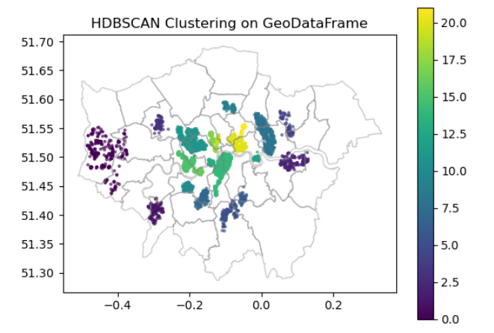

In the HDBSCAN analysis, setting min_cluster_size to 50 means that regions with fewer than 50 data points will be labeled as noise or individual data points. Ultimately, we obtained 23 clusters, with some clusters distributed not only in the central areas of London mentioned above but also in Brent, Hillingdon, Kingston, and Greenwich.

为了进一步研究伦敦各区域的ghost room 是否存在空间上的局部聚集或分散,我们选择用局部莫兰指数和